**1. Abstract:**

This project aims to develop a centralized educational website for college students, providing easy access to syllabus, reference books, notes, and YouTube video lectures across different years and departments. The platform will feature a structured categorization system, enabling students to quickly find relevant study materials. A search and filter option will enhance usability, while a syllabus repository ensures updated course outlines. Additionally, a notes section will allow faculty to share study materials, and a video library will provide curated lectures for better understanding. The website will be designed with a responsive and user-friendly interface, making it accessible on both desktop and mobile devices. Developed using modern web technologies, this platform will improve accessibility, and enhance academic performance for students.

**2. Introduction:**

In the modern educational landscape, students often face challenges in accessing well-organized and reliable study materials. With diverse subjects and vast syllabus, finding the right resources, such as syllabus, reference books, notes, and video lectures, can be time-consuming and inefficient. To address this issue, we propose the development of a centralized educational website that will serve as a one-stop platform for students from different years and departments.

This website will provide a structured repository where students can easily find their course syllabus, recommended books, study notes, and relevant YouTube video lectures. The platform will include features such as categorized study materials, a search and filter option, and a user-friendly interface, ensuring seamless access to academic content. Additionally, students and faculty members will have the opportunity to contribute study notes, fostering a collaborative learning environment.

By leveraging modern web technologies, the platform will offer a responsive and scalable solution, making it accessible on both desktop and mobile devices. This project aims to improve academic resource accessibility, and enhance students' overall learning experience.

**3. Problem Statement:**

To improve accessibility and efficiency in finding academic resources, students often struggle with fragmented study materials, such as syllabus, textbooks, notes, and video lectures, spread across multiple platforms. This results in wasted time and confusion. Additionally, there is a lack of a centralized system where students and faculty can easily share and access these materials. To address these issues, there is a need for a unified educational platform that consolidates resources, promotes collaboration, and enhances the learning experience for students.

1. **Objectives:**

* **To provide centralized access to academic resources** by creating a unified platform where students can easily find and access syllabus, textbooks, notes, and video lectures across various courses and departments.
* **To implement search and filter functionality** that allows students to quickly locate relevant study materials based on criteria such as course name, department, year, and type of resource.
* **To enable efficient content management** by allowing faculty and administrators to upload, update, and organize academic resources, ensuring that all materials remain current and well-structured.
* **To incorporate feedback and evaluation mechanisms** by enabling students to rate and review study materials, providing valuable insights to help improve the quality and relevance of resources shared on the platform.

1. **Proposed System Architecture:**

The System architecture of the “AI Driven Crop Disease Prediction”:

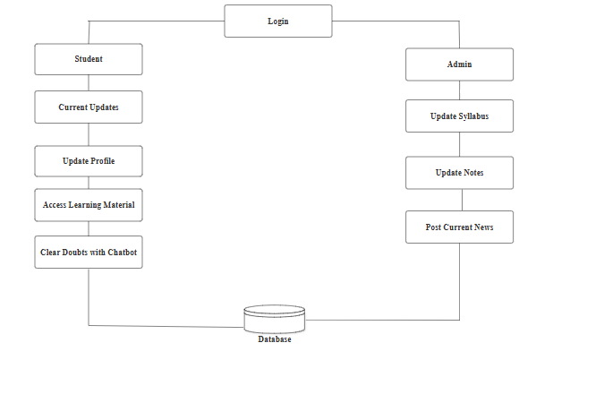

1. **Module:**

* **User Authentication Module**: Allows students, faculty, and admins to log in, register, and manage their account
* **Dashboard Module**: A central interface where users (students, faculty, and admins) can quickly access relevant resources.
* **Syllabus Management Module**: Manages course syllabus for different departments and years.
* **Video and Multimedia Module**: Manages YouTube videos, lectures, and other multimedia resources relevant to courses.
* **Search and Filter Module**: Allows users to quickly find resources by applying various filters.
* **Feedback and Rating Module**: Collects feedback on study materials, videos, and other

resources to ensure quality and relevance.

1. **System Requirement:**

* Software Requirement:

1. Front-End Development: HTML, CSS, JavaScript.
2. Back-End Development: PHP.
3. Database: MySQL.
4. Operating System: Windows 11.

* Hardware Requirement:

1. Client: PC's, Laptop.
2. Minimum 1 GB of RAM.

1. **Conclusion:**

The development of a centralized educational website for college students will simplify access to essential resources such as syllabi, reference books, notes, and video lectures. By offering user-friendly features like search and filter options, content management, and collaborative tools, the platform enhances the learning experience. With modern web technologies, the platform ensures accessibility and responsiveness across devices, fostering a more efficient and interactive learning environment. This website will ultimately support student success and improve the overall educational experience for both students and faculty.

1. **References:**

1. Bahrami, M., & Lee, J. (2020). A Web-based Collaborative Learning Platform for Students: Design and Development. International Journal of Educational Technology.
2. Gauthier, M., & Jones, K. (2018). Building a Responsive Learning Management System with a CMS. Journal of Educational Technology. 34(2): 115–130.
3. Cheng, Y., & Wang, C. (2019). Leveraging Cloud-Based Content Management Systems for Educational Resource Sharing. Proceedings of the International Conference on Web Information Systems and Technologies. 17: 234-245.
4. Kaur, R. (2021). Web Development Frameworks for Educational Websites: A Comparative Study. Journal of Web Development & Design. 30(4): 567–578.
5. Patel, S., & Singh, R. (2022). Enhancing Student Learning with a Centralized Educational Resource Platform. International Journal of Computer Science and Information Technology. 40(6): 210–221.
6. Kumar, A., & Gupta, R. (2021). Building Scalable Web Applications for Education Using Cloud Infrastructure. Journal of Cloud Computing and Education. 6(3): 112–125.
7. Chang, L., & Zhao, J. (2020). Designing User-Friendly Educational Websites for Students: Best Practices. International Journal of Human-Computer Interaction. 36(1): 45–60.
8. Sharma, N., & Verma, R. (2020). The Role of Artificial Intelligence in Educational Websites: Trends and Future Scope. Journal of Artificial Intelligence & Education. 15(3): 78–90.

**Class: T.Y Div: B Batch: T2**

|  |  |  |  |
| --- | --- | --- | --- |
| **Sr. No** | **Roll No.** | **Name** | **Sign** |
| 1 | 39 | Pooja Subhash Patil |  |
| 2 | 40 | Sakshi Sagar Patil |  |
| 3 | 42 | Sejal Vinod Navale |  |
| 4 | 43 | Mrunal Arvind Bhosale |  |
| 5 | 47 | Sanika Suresh Sankpal |  |

Date: /02/2025

Place: Kolhapur

**Prof .N. N. Patil Radhika J . Dhanal**

(Project Guide ) (Project Coordinator) (HOD)